1. lets see the question “Delete Integer value in the document”
2. please go through the below link to understand the delete functionality in firebase

<https://firebase.google.com/docs/firestore/manage-data/delete-data>

please practice and implement in pycharm by following the above link

1. iam highlighting the attribute which iam going to delete in the document, please go through the below screenshot

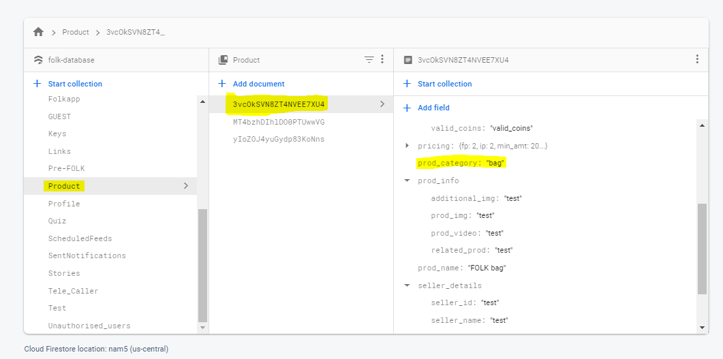

* deleting integer, string, Boolean for these things the process is same , so in the above screenshot iam highlighted the string attribute
* docs = db.collection(u’product’).document(‘3vcOkSVN8ZT4NVEE7XU4’)
* data = {

u’product_category’:firestore.DELETE_FIELD

}

* docs.update(data)
* after that , filed is deleted in the document
* similarly same syntax we follow for number, intezer, Boolean,map